**Finding the best database management software to use in this project**

Goal of this research to consider the functional and nonfunctional requirements of out project and find the best database management software that can easily cater those requirements.

First step is to decide whether to use relational or non-relational database.

Relational databases require lot of effort to build and maintain, but or non-relational database require effort around 10% cost to Relational DB which very effective in a project in a tight time frame. Also NoSQL database performance is better than relational database.

Since we are developing a member management system that also includes event management our best approach to this is to use an NoSQL database (document database) that we can easily cater the changing requirements and manage lots of attributes. In this scenario there are few relations between entities, that also a reason to use a NoSQL database.

**Best NoSQL Databases**

* According to popularity.

As the results in “DB-Engines” website in August 2018.

|  |  |
| --- | --- |
| **Database System** | **Score** |
| MongoDB | 350.98 |
| Amazon DynamoDB | 51.66 |
| Couchbase | 32.96 |

Database popularity means more support for the data base and less chance to have critical errors in the system because its tested in the real world more than any document database.

* Using JSON as data format

JSON data can be easily accessed in java script.

List of JSON databases.

1. MongoDB
2. CouchDB
3. DocumentDB
4. MarkLogic
5. OrientDB
6. RethinkDB

* Performance

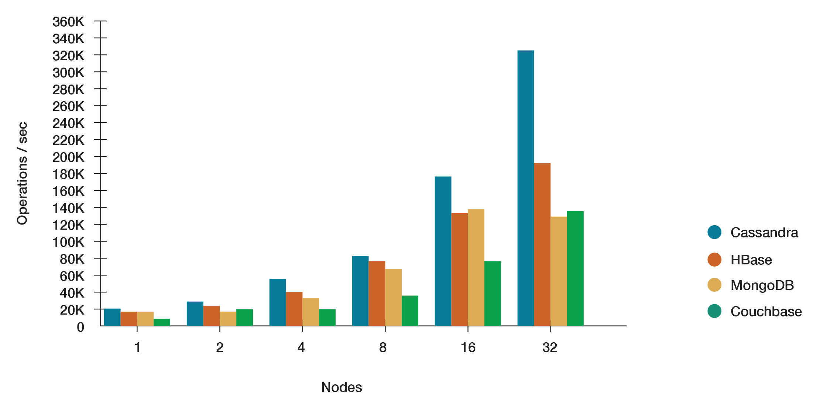

*Figure: Datastax databseperformance chart*

As per this research I find that MongoDB is a good database that can be used in this project, mainly because of its popularity it is useful when learning and overcoming problems quickly because of the wide usage of the database, which will come in handy when developing in a tight time frame.

**References**

[1]"NoSQL vs Relational Databases (When to Use What?) - DZone Database", dzone.com, 2018. [Online]. Available: https://dzone.com/articles/nosql-vs-relational-databases-when-to-use-what. [Accessed: 15- Aug- 2018].

[2]"Relational versus Non Relational Database – Hacker Noon", Hacker Noon, 2018. [Online]. Available: https://hackernoon.com/relational-versus-non-relational-database-d5d1c439fb86. [Accessed: 15- Aug- 2018].

[3]"DB-Engines Ranking - popularity ranking of document stores", Db-engines.com, 2018. [Online]. Available: https://db-engines.com/en/ranking/document+store. [Accessed: 15- Aug- 2018].

[4]"List of JSON Databases", Quackit.com, 2018. [Online]. Available: https://www.quackit.com/json/tutorial/list_of_json_databases.cfm. [Accessed: 15- Aug- 2018].

[5]"NoSQL Comparison Benchmarks", DataStax: always-on data platform | NoSQL | Apache Cassandra, 2018. [Online]. Available: https://www.datastax.com/nosql-databases/benchmarks-cassandra-vs-mongodb-vs-hbase. [Accessed: 15- Aug- 2018].